Title

Author name¹, author name^{2#}

¹ Author affiliation
² Author affiliation

# Corresponding author information:

Graphical abstract

replace image with compressed image file (JPEG, PNG, etc., 6-inch width maximum)
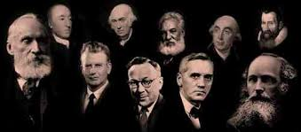

Abstract

Background. Insert text here.
Aim. Insert text here.
Relevance for patients. Insert text here.

Keywords: keyword 1, keyword 2, keyword 3, etc.

1. Introduction

Insert text here.

2. Insert section title here

Insert text here (optional).

2.1. Insert subsection title here

Insert text here.

replace image with compressed image file (JPEG, PNG, etc., 6-inch width maximum)
Figure X. Insert figure legend here.

Continue text here.

Table X. Insert table legend here.

Continue text here.

3. Discussion

Insert text here.

Acknowledgements

Insert text here.

References

Insert references here.

